>
Teknisk uddybning af generelle egenskaber for Sag og Dokument  Denne vejledning kan frit anvendes af alle. Citeres der fra vejledningen i andre publikationer til offentligheden, skal der angives korrekt kildehenvisning.  Vejledningen er udarbejdet af OIO-udvalget for tværgående sags- og dokumenthåndtering.  Kontaktperson for OIO-udvalget:  Projektleder Carsten Rohde  Mailadresse: carr@itst.dk  Direkte telefon: +45 3337 9273 |  | Udgivet af:  IT- & Telestyrelsen  IT- & Telestyrelsen  Holsteinsgade 63  2100 København Ø  Telefon: +45 3545 0000  Fax: +45 3545 0010  Publikationen kan hentes  på IT- & Telestyrelsens  Hjemmeside: http://www.itst.dk  ISBN (internet): [Angiv]  ISBN: [Angiv]

Technical deepening of general characteristics for Case and Document

The Reference Committee for file and document area
XX.XX 2010
>
Contents >
1. Introduction 5
1.1 Reading guide 5
1.1.1 Audience 5
1.1.2 Notation 5
2 From the business object to the Service Interface 6
2.1 Objectet’s ”Anatomy” 6
2.1.1 Object ID 8
2.1.2 ObjectRegistration 8
2.1.3 Attributes 9
2.1.4 Relations 9
2.1.5 States 10
2.1.6 UML Diagramming 11
Example Objects - Document 13
Registrering 13
Attributter 15
Relationer 16
Tilstande 17
Total virkning 19
2.2 Timing Change - Temporal Properties 20
2.2.1 System time 20
2.2.2 Registration 21
2.2.3 Effect 22
2.2.4 Example 24
3 Service Operationer 25
3.1 Løsningsarkitektur 25
3.2 Input 25
3.3 Output 26
3.3.1 Fejlhåndtering 26
3.3.2 Transportprotokol 26
3.4 Data Service API 26
3.4.1 Opret 26
3.4.2 Læs 28
3.4.3 Opdatér 28
3.4.4 Slet 29
3.4.5 Import 30
3.4.6 Passiv 30
3.4.7 List 31
3.4.8 Søg 31
Hændelser 32
Baggrund 32
Hvad er en hændelse? 32
Operation API for Hændelser 33
Hændelsesfordeler 33
HændelsesModtager 34
4 Referencer 35

Reading guide

1. Introduction
This document relates to file and document area's specifications published for consultation 12th October 2009. Specifically, the following is a technical elaboration of the "General characteristics of service interfaces at the case and document the area" and contains a more detailed review of the general characteristics of the various service interfaces. This is the document that the consultation letter in connection with the specifications cited as further evidence of the general characteristics.
This document describes the objects, conditions and relationships, but is mainly active in detail with the temporal properties (recording and effects), and the specifications related operations.
It should further be noted that IT and Telecom Agency has launched a POC (Proof of Concept) to illustrate the logic specifications can be implemented in systems. This document is inspired by the first POC in the area who have used the specification "Specification of service interface for the document" as a basis, why service interface document used as an example in large parts of the material.

Audience
The target audience for this document is primarily architects with software suppliers who must implement these interfaces. In the second series of architects in the public sector who are considering buying interfaces as described in the specifications.

Notation
- UML - A UML 2.0 notation used in diagrams and domain models.
- Pseudo code - used pseudo code in the examples
- Use XML fragments in some of the examples
- Code / Pseudo Code is written in NewCourier font.

From the business object to the Service Interface
Reference Architecture² (Reference Architecture for case and document field (EDM), 2008 ") has defined a number of business objects, and include them subsequently translated into specifications for service interfaces in the areas:

- Case
- Document
- File structure
- Organization
- Classifikation

The specifications have the following implicit assumptions:

- They specify the information an object contains and how operations affect the
- A service interface is represented as a service endpoint with the methods (operations).
- Service interface logical structure is returned after a service call.

The description of objects in the following additional documentation regarding the service interfaces based on that there are some common general properties of objects.

Objectet’s ”Anatomy”
To define an extended generalized model for all objects in those specifications, as shown in Figure 1 below. The model provides an overview of the objects, attributes, states and relationships and temporal properties (see later on efficacy and registration as discussed in more detail in the section on "Time-based changes - temporal properties).
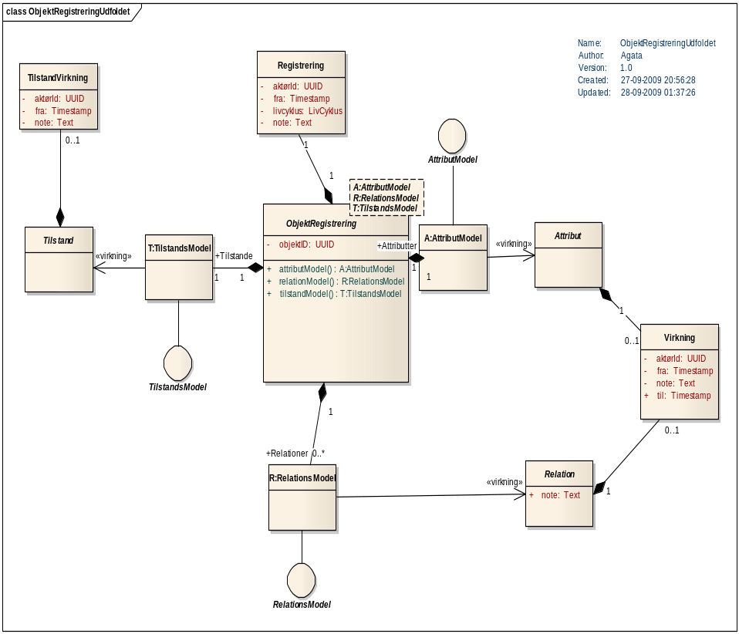
Figure 1 Object registration - with stereotypes

All concepts in the above chart is explained in the following table:
Chart | Explanation
ObjektRegistrering | Object registration is a super type, which represents the state of a resource after the call to a service operation.  Object recognition is modeled as a template type that is dependent on a AttributModel, a relational model and a state model.  Specifically, this means that subtypes, such document shall become bound to the super type, they define their own models.
Registrering | An object recognition has assigned a unique registration representing transaction time of service operation.
Virkning | Effects are used to equip parts of the object (Attributes, Relationships, States) with properties relating. perspective.
TilstandVirkning | A state may also have an effect but it must not have an "expiration" period.
AttributModel | At a general level AttributModellen abstract. It is implemented for each Service Interface and describes the attributes of service has.
RelationsModel | At the general level of relationship-model abstract. It is implemented for each Service Interface and describes the relations service has. Of the relationships in an object called the Relational Model
TilstandsModel | At a general level state model abstract. It is implemented for each Service Interface, and describes what conditions service has.
Attribut | Represents a data structure which is a sub-element of the object. Attributes can be associated with Impact.
Relation | Represents a reference to a resource (foreign business object) to be accessed via a service. Relationships can be assigned Effect.
Tilstand | Condition specifies a semantic attribute of the object. We operate with little state characters per second. object, each with defined specific values.

Object ID
The object is assigned a globally unique objektID of type UUID when it is created. Although the object state changes and content over time, its UUID is not changed - it's part of the service's business logic. UUID used to link data together across services and across the Records and Effects.

ObjectRegistration
An object in this context is actually an instance of an object as it appears at any given time of recording - it refers to as the body registration or Object (Ix, rx).

In this way, every object represented by one or more object records. An instance of an object retains its Object Type and objektID in different records.
O(i1,t1), O(i1,t2), O(i1,t3) ...

An object recognition is immutable, i.e, it cannot be changed. Instead, the service form new instances of ObjektRegistering, with new file recording, updated values and possibly with a changed lifecycle.
En ny ObjektRegistreringsinstans bliver skabt efter hvert af følgende operationskald:
- Opret
- Ret
- Slet
- Importer (?)
- Passiver (?)
There can only be edited and deleted in light of the recent registration of the instance. However, you can list and / or search all records of objektinstansen. (See also section on "Service Operations"for further description of the operations associated with the service interface).

Attributes
An attribute is an element that has an impact period. This allows content of the attributes change over time. Objects may contain attributes. For example, document a class attribute, called the document properties:

DokumentEgenskaber
Titel:Text
AndenTitel:Text
...

Relations
A relation expresses a reference to a resource in another service, called foreign object. Relationship effect period. This allows the relation content changes over time.
Of the relationships in an object called the Relational Model.
As an example a subset of relational model for the document in Figure 2, and it appears that:
- Document has a relation to a number of resources in the service document (itself or another), and the relationship is called "Annex”.
- There are still a relation of cardinality first. n to the service document, titled "Another document”.
- There is a relationship with cardinality 1 to the service called Document Assumptions.
- Document has a relation to a number of resources in service Archive.
- The figure also shows that the document has a single relationship with actor and a plural relation to Actor.

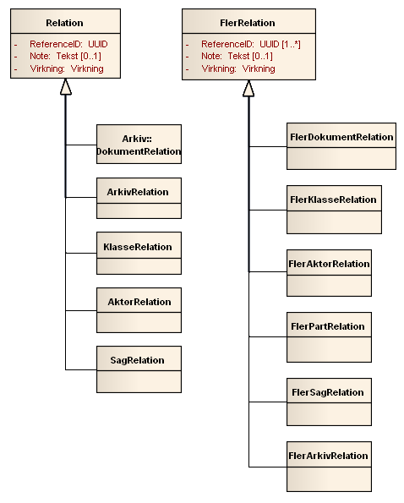
Figur 2 Relational Model, shown here for some of the relationships defined in Document.

States
States are defined with fixed outcomes, as state is an attribute that can describe anything about the object on a time axis. It may, for example. describe momentum, publishing, and similar quality.
States may also have an effect, but this works a little differently than the general effect. A state action has a "from" time, but nothing "to". This allows a state only replaced by another state..

UML Diagramming

Temporal pattern and stereotype <<virkning>>
We have chosen to use repetitive (repetetive?) patterns to illustrate how temporal effect linked to model elements. To end with straightforward diagrams, it was decided to use stereotypes to present the temporal pattern of effect.

We use stereotypes to present changes over time:
- Impacts on Modes
- Effects on Attributes
- Effect on Relationship
- Special adaptations specific to the individual Service Interface.
We represent the stereotype <<virkning>> over a UML association to indicate that in reality is a collection of elements, each with their effect.
We say that we filter object in terms of an effective range when selecting a subset which corresponds to a specific effect period.
This pattern and notation follow Martin Fowler's Temporal Pattern, see [Fowler].
Below is an example of a subset of UML diagram for the document in which the stereotype <<Virkning>> is used in target-role the endpoint of the association of document relationship model. In reality, there is a collection of links of type File, each with their effect. But when the effects can not overlap, is that each time exactly (only?) single file relation, valid.

Collection<Arkiv>
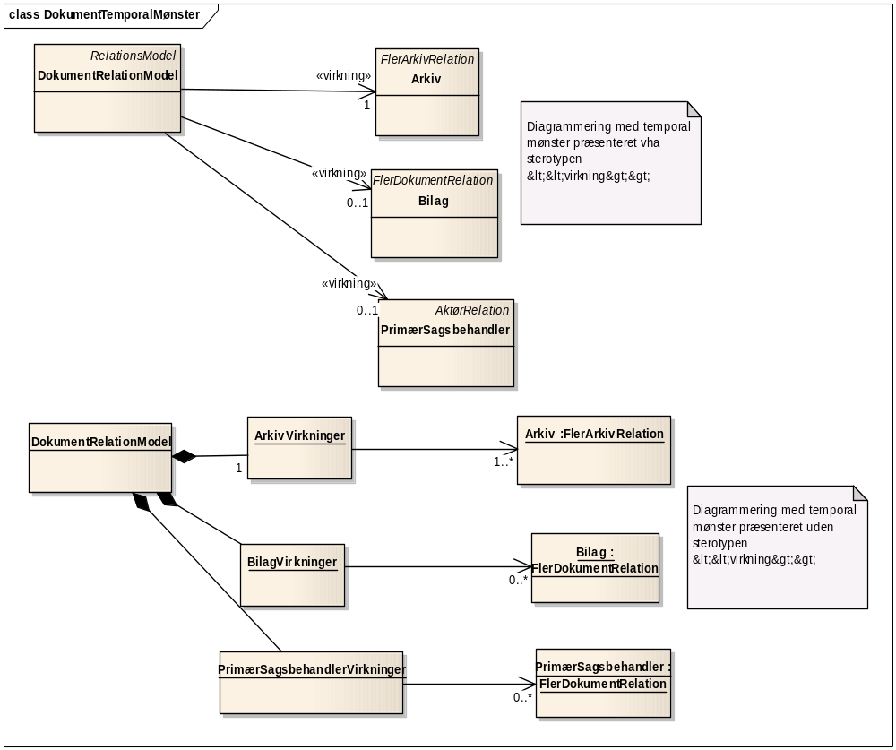
Figur 1
Illustration 1: Temporal mønster vises i UML diagrammer med stereotypen <<virkning>>

Figur 3: Temporal pattern appears in the UML diagram with stereotype <<virkning>>

Template classes and <<binding>>
We use a parameterized class (aka template types) to define a general structure as a template.
Its functionality can be implemented by tying one type for the parameterized class - and when it binds to specify the types that are tied to the parameters. A classic place where parameterized classes are used in Collection Library in Java / C #..
Object recognition is a parameterized class, with the following parameters:
- A is a parameter of type AttributModel
- R is a parameter of type relation model
- T is a parameter of type condition model
Instead of a class specializing a template class, it can be stated that the class bound to the Template class.
- This is done by using a dependency association with <<bind>> stereotype.
For example below shows that the Document is tied to the object model with the following parameters:
- • DokumentAttributModel instead of A
- • document related model instead of R
- • Document state model instead of T.

Example Objects - Document
As described in the previous chapter is accompanied by a number of general properties for each object. In this chapter, a concrete example of an information model - the model for the document - will be reviewed in order to describe how the specific model relates to the general characteristics.

Registrering

The figure below shows a detail of the information model document. Object Document contains, in accordance with the description of the general characteristics of an ID of type UUID. Additionally, document a user-facing key. The purpose of the user-facing key is to have an unchangeable identification of the document, as opposed to the document ID can be presented to the user.
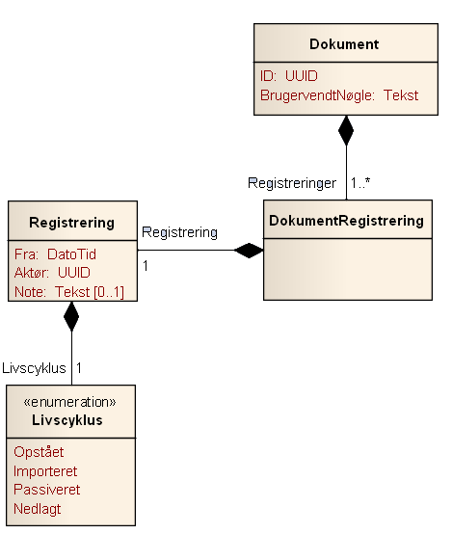
Figur 4

A document containing a number of records called the document registration. Creating a new document registration, each time performed an operation that modifies the document attributes, conditions, or relationships. Element Registering a specific date and time of registration, a reference to the actor who has made the registration, and document lifecycle. Finally, it is possible to attach a note to the registration.

Attributter

For every object is assigned a number of attributes. In the information model document, put these attributes in an element called DokumentAttributListe. For a given document registration, there is just one DokumentAttributListe. For Document, there is just one type of attribute: the attribute Properties, which is of type DokumentEgenskaber. The actual type of document properties consists of a number of fields which are described in the standard for document. In this context, two facts are worth noting:
- First, it represents the Title field in the Properties attribute of the document Object Name. Title is the actual name for generic title Object Name.
- Second, the document properties associated effect. This means that the document properties may change over time. For a concrete document registration can however see which properties that have been effective at what times.
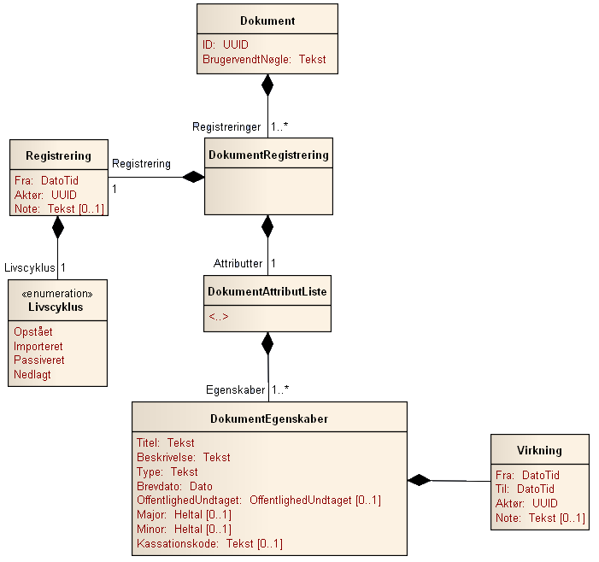
Figur 5

The symbol <..> in the element DokumentAttributListe in Figure 6 indicates that allowed for a concrete application of the information model document to add additional attributes. However, it is a requirement that these attributes must have effect. Figure 7 indicates an example of a concrete application, which is added an additional attribute - English translation:
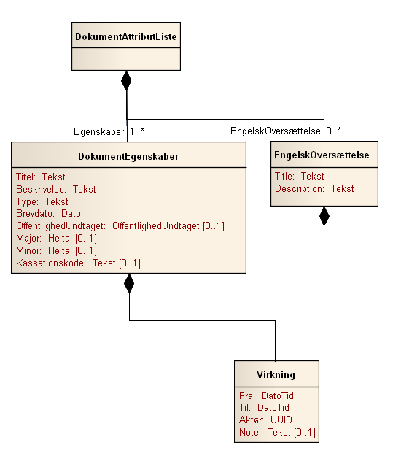
Figur 6

Relationer

For every object is assigned a number of relationships. In the information model document placed these relations in an element called the document related list. For a given document registration is attached just a document related list.
The symbol <..> in the element related document list in Figure 8 indicates that permitted for a specific use of the information model document to add further links. However, it is a requirement that these relations must be either of Relationship type or type multi-relation. Figure 10 indicates an example of a concrete application where there is an added relationship - Document Type:

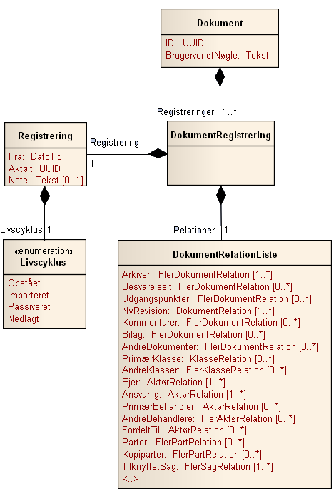
Figur 7

All relations inherit either from the general element Relations, which represents a reference to one other object of a particular type or from the general multi-component relationship, which represent references to a number of objects of a particular type. Figure 9 indicates the model for Relational and multiple relationship. Note that both Relational as multi-link takes effect.
The actual reference is represented in the model by using a UUID.

Tilstande

For every object is assigned a number of states. In the information model document placed these attributes in an element called the document status list. For a given document recording falls just one document state list. For Document, there is precisely one state, namely state Propulsion, which is of type document progress. The actual document type propulsion consists of two fields, namely the Status field that indicates the state's status as well as field effect, which indicates that the condition has effect. It is thus possible from each document state list to see what the document Progress has been at different times. Note that the impact of modes, mode effect, differs from the general effect of not having a To field. This is due to the conditions in contrast to attributes and relationships can not be "holes" in the registration. One document must always have a propulsion. To field would be redundant and are therefore not included in the information model.

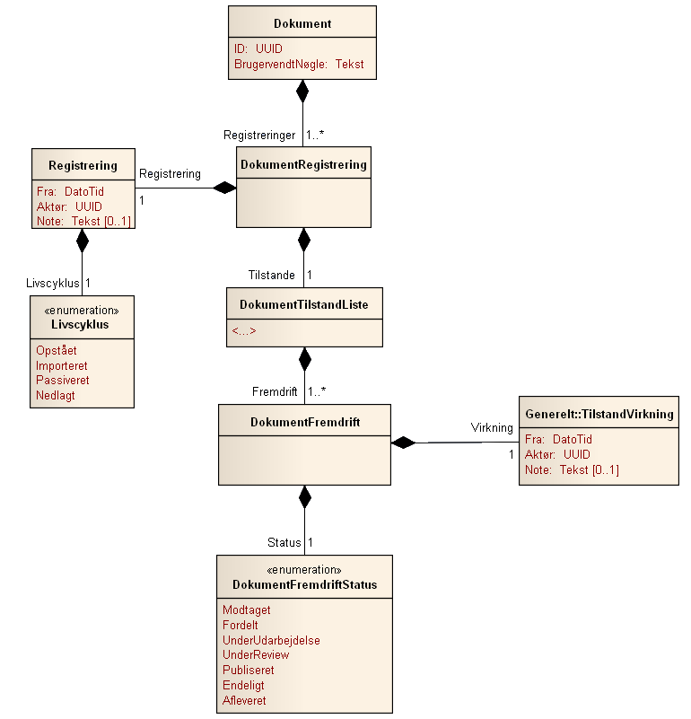
Figur 8

The symbol <..> in the element document status list in Figure 11 indicates that it is permissible for a concrete application of the information model document to add additional states. However, it is a requirement that these relationships must have status (which is a enumereret list) and effect (type mode effect). Figure 12 (10?) indicates an example of a concrete application where there is an added condition - Approval:
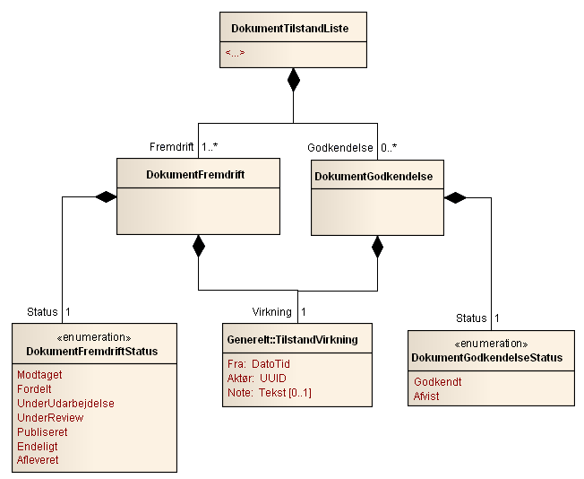
Figur 9

Total virkning

Figure 13 (11)? shows the overall information model for the document. As the chart shows, in addition to the already described elements added an extra effect on document relationship. This effect indicates the total effect of the document. Document has a number of mandatory elements: Properties is an example of such a mandatory feature, Owner is another. Although these elements are mandatory, there may be gaps in their effect. However, there may be only a hole in a compulsory element effect, if the document at the time had no effect. The document indicates the total effect is, the periods in which at least one of the document elements (including all mandatory elements) had effect.
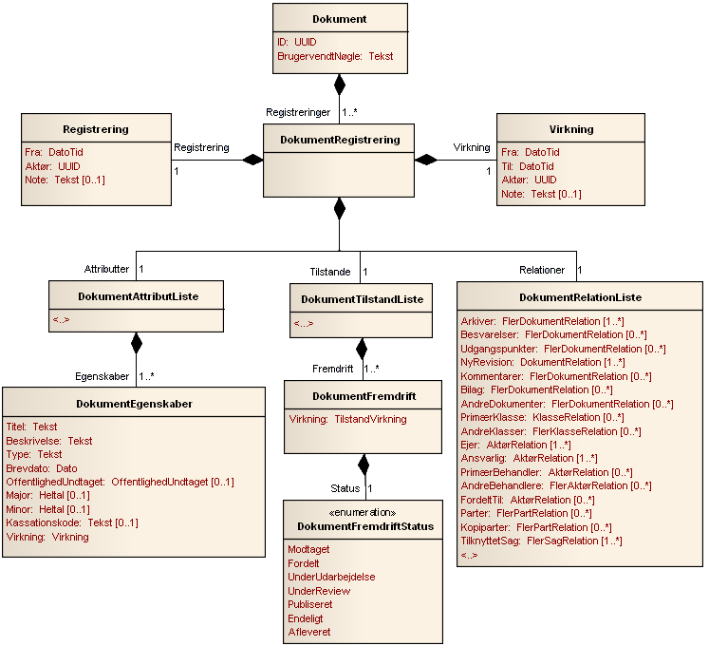
Figur 10

Timing Change - Temporal Properties
The concept of temporal characteristics comes from database world, where it provides the opportunity to represent records, which change over time in a database. We use this structure to get the opportunity to access information not only on existing relationships but also on past and future filings.

System time
The concept of system time used to define when the service's operation is called (elsewhere called transaction time). System time is represented by a timestamp:
Timestamp = 2009-10-01T23:59:59.9999

Besides the normal timing, we also need to specify logical minimum and maximum of system time:
- minimum denotes the earliest time that can be expressed in system time.
- maximum denotes the latest time that can be expressed in system time.
Intervals ]minimum, maximum[therefore means in practice ”ALLTIME”.

Registration
Every object consists of a series of records. A record corresponds to the knowledge about the object, which was available at the time of an operation call. We let the record be immutable whereby it is not subject to change.
Instead of being formed new secondary registrations for new operation calls.
This means that we consider an object as a collection of keys and values, where registration is key, and object registrations values. In computer science terms, we are dealing with a Map.

D(ID1) : Map<Registrering, Document>
= [R1->D(ID1, t1), R2-> D(ID1,t2), ... Rn->D(ID1,tn)]

UML model for registration:

Registrering
fra:Timestamp
livscyklus:LivsCyklusEnum
aktørRef: UUID

Explanation of fields:
Fra | Timestamp is automatically added to the service with the time of operation called.
Livscyklus | An Enumeration of options (Start, Imported, liabilities, Disbanded).
Aktør | A reference to the responsible actor - it can be user or user organization. The value is automatically added by the service.

Example.
The Document may stereotype realized using the following XML snippet:
<Document xmlns="urn:oio:sagdok:1.0.0" … >
<ObjectId>112</ObjectId>
<Registration>
<lifecycle>Opstået</lifecycle>
<actorID>117</actorID>
<from>-minimum</from>
</Registration>

…
</Document>

Effect
Effect allows you to specify a number of alternative versions of the same element.
Virkning
fra: TimeStamp
til:TimeStamp
aktør: Aktør
note:String

Forklaring af felterne:
Fra | Starten af Virkningsintervallet.
Til | Slutningen af Virkningsintervallet.
Aktør | En reference til den ansvarlige aktør – det kan være bruger, eller brugerens organisation. Værdien bliver automatisk tilføjet af servicen.
Note | Can be used as comment.

Business logic
- The time interval shall be consistent, "from" must be less than "to"
- If no interval is specified, the default value
] minimum , maximum[
- The time interval may be one of the following:
  - [t_0, t_1] - closed interval
  - ]minimum,t_0], [t_0, maximum[ - half open interval
  - ]minimum,maximum[=ALLTIME open interval – in practice always equal
- Actor is optional. If not specified, the default value "Organization ID".
- Frequency of an effect within the same recording might be incoherent, ie. we allow gaps.
- Closed intervals for an effect within the same ground can not overlap.
- Semi-Open and open intervals may well overlap in input. It will be of service converted to closed intervals.
Example:
UPDATE( [t1, maximum]: titel-> ”hej” ) → R1
UPDATE( [t2, maximum]: titel-> ”hej2”)-> R2
R2 = [t1,t2]: titel->”hej”, [t2,maximum]:titel->”hej2”

Explanation of stereotype <<Virkning>> - the document properties as an example
The stereotype <<virkning>> is used in UML diagrams as a notational shortcut.

Document defines a DokumentAttributModel and has annotated the relationship between DokumentAttributModel and document properties (attribute) with the stereotype <<>>. The pattern tells us that although the document at a given time have exactly one element of the document properties, we have in reality a collection of document properties.

XML fragment below shows how a document can have two impacts of the same Attribute - document properties.

The first has effect from the date 01.10.2009 title ”Hej, hej verden!!!”.
The other has the effect date 01.12.2009 title ”Hejsa”.

<Document>
<DocumentProperties>
<Validity from="2009-10-01T23:59:59.9999" to="maximum"/>
<Title>Hej, hej verden!!! </Title>
</DocumentProperties>
<DocumentProperties>
<Validity from="2009-12-01T23:59:59.9999" to="maximum"/>
<Title>Hejsa</Title>
</DocumentProperties>
</Attributes>
….....
</Document>

Example
A client calls the Document Services repeatedly.
- Create Document and records the following effects of the attribute "title":
  - From [t1, t2) is the value title = Hej
- Edit document
  - From [t2, max) is the value title = Hello
- Read the document (no time specified)
  - The returned document registration is filtered by default effects after day-date, and it corresponds to the title " Hej". A title attribute will be returned as part of the registration.
- Read the document (from = t1, maximum).
  - The returned document registration is filtered after-effect interval [t2, max) and returns 2 values for the title as part of data: Hej and Hello.

Service Operations

Solution Architecture
With the definition of operations, we move away from Information Models and semantic standards into solution architecture. It is not data - that is services that can address data is the key.
This diverts a number of technical requirements for
- Infrastructure
- Safety, Sign On, Rights Management
- Service Level Agreement - for service consume
- Lifecycle Management - for Service Provider
- SOA Governance - the ecosystem's life
The above technical requirements not discussed in this context but will be addressed in the forthcoming guidance on technical requirements for data services that use the file and document standards.

Input
Each operation at each service interface is defined by its own model.
The naming follows the rule: "service operation inputs. For example, states Schema to Document Create: DocumentCreateInput.xsd.
The design of the API has been paid the utmost attention that it should be easy to build clients that can use the service end points. This includes defining a business logic that assigns default values for mandatory XML elements, so service can be "forgiving" towards the client.
Most modern systems allow xml parsing take place automatically in special classes that are generated from schemas. This provides maximum security type, and developers do not work with XML code. Derived schemas can use the same classes. Schemes with a new structure requires you to compile new classes.

XSD → Autogenererede parserklasser

To avoid unnecessarily complex programming, each object specifications ensure that input structures located in the same target namespace and extend the same type as the information model.

Output
The service always returns metadata for the last object registration, as defined in the information model. The returned data contains all the changes made by the service, and will usually be different from the input data. The exception here is the search / list that returns collections that contain object records.
The naming follows the name of the business object for the service. For example, states Schema to Document: Document.xsd.

Error Handling
If the call is unsuccessful, it returns an error message. The error message contains an error code and message.

Transport protocol
You can deploy the service using
- REST
- WS-* stack
- Asynchronous messaging
Each organization's requirements for such Security is crucial to the election.

Data Service API
We see service as a data layer and expose only data operations. These are CRUD operations + search, list and liabilities / import.

Opret
Operation Create - CREATE is responsible for creating an object and an object recognition and return object registration.

CREATE(DocumentCreate.xml) -> D(UUID1,t1)

Input
The model inputs for each Service Interface must be a forgiving, and allow to use as little information as possible to create an Object. If there are mandatory elements, it is a design choice whether the business logic must take care to define default values for these.

OpretInput
virkning:Virkning
attributter [0..n]:Attribut
relationer [0..n]:Relation
tilstande [0..n]:Tilstand

Elementforklaring:
Element | Obligatorisk | Default værdi tildelt af systemet
Virkning | Nej | ]minimum, maximum[
Attributter | Nej/Ja | Custom business logic
Relationer | Nej/Ja | Custom business logic
Tilstande | Nej/Ja | Custom business logic

For example, an empty Document object created by calling the Create operation in document services with the following XML fragment:

<oio:Document xmlns:oio="urn:oio:sagdok:1.0.0" xmlns:xsi="http://www.w3.org/2001/XMLSchema-instance" xsi:schemaLocation="urn:oio:sagdok:1.0.0 DokumentCreateInput.xsd " />

Output
The return value is an object registry that contains the new UUID, representing the return value from a call to READ (UUID1).

Business Logic
The service creates a new object and assigns it a unique, global UUID.
Life-cycle mode is set to "arise ".
The service creates an object registration, and "populate" the data structure as specified by the input structure.

Læs
Operation Læs – READ – responsible for returning the last object registration.

Input
As input indicated objektID and an optional effect interval.

Parametre:
Element | Obligatorisk | Default værdi tildelt af systemet
objektID | JA | Fejl!
virkningsInterval | Nej | NU

Output
Output is Object Structure as defined by the Information Model, and the corresponding Schema. Eg. returned from a document service xml document generated in Document.xsd schema.

Business Logic
- Returns are always the last object registration
- All objects can be read - even the stamped out.
- An indication of the impact range is filtered through object registration.
- Called fail if objektID not exist.

Update
Operation Update - UPDATE - have a responsibility to create a new object recognition, and introduce the changes indicated in the Input structure.

UPDATE(DocumentUpdate.xml) → D(UUID1,t1)

Input
Basically we would like to settle for having only the changes as an input parameter. However, it is a little complicated, with collections taking could delete a collection element.

Element | Obligatorisk | Default value assigned by the system
objektID | JA | Error!
Attributter | NEJ | Former registration data continued
Tilstande | NEJ | Former registration data continued
Relationer | NEJ | Former registration data continued

Output
The new record, representing the return value of READ.

Business Logic
- When an object directed, produced a clone of the elements to be changed and can add elements that do not exist before.
- Each of the original elements that are changed get registreretTil = ts (), while the new elements will registreretFra = ts (). The new element, the new values.
- If you try to edit an object or a udstemplet udstemplet element, it would be like to create it again - ie. formed no clone.
- If the UUID is lacking or can not be matched by an existing object, wrong call.
- If an item in a collection is missing, it corresponds to deleting.

Slet
Slet has responsibility for creating a new registration with Lifecycle mode set to "SEEK"(”NEDLAGT”).
Delete(uuid1) → D(UUID1,t1)

Input
Et objektID.

Output
Den nye registrering bliver returneret, svarende til READ operationen.

Business Logic
- An object with the specified uuid must be defined and shall have no status "NEDLAGT ".
- • Life-cycle variable is changed to "NEDLAGT ".

Import
Imports have a responsibility to create a new object and a new object registration service, based on data downloaded from another service (the original service).

IMPORT(DocumentImport.xml) → D(UUID1,t1)

Input
A complete Object that includes objektID, representing the return value from READ in the original service.

Output
The service returns the new record, corresponding to a call to READ.

Business Logic
- A new object and a new ObjektRegistering is created - but service does not generate a new UUID.
- UUID must be configured in Input Structure
- Life cycle is set to "imported".
- When an imported object is read, you must stipulate StdRetur that 'filings before imported' has not occurred in this service.

Passiv
Passiv is responsible for checking that the Service is responsible for maintaining an Object. Especially do not subscribe to events.
Passiv(UUID1) → D(UUID1,t1)

Input
An objektID.

Output
The service returns the new record, corresponding to a call to READ.

Business Locgi
- When an object passivation is the only life cycle state of 'passive' that will be put with registreretFra = ts ()
- Passive means that the maintenance of the object does not occur in the service.
- When a passivated object is read, you must stipulate that StdRetur 'filings after passivated' does not occur in this service.

List
List used to work with time perspective, and therefore can filter on Registration Interval and Effect Interval.
LIST([UUID1,..UUIDn], ValidPeriod, RegistrationPeriod) → [D(UUID1,t1), D(UUID1,t2) ... D(UUID2,t3),... ]

Input
- List of ObjektId - Compulsory
- Effective Period - optional
- Registration Period - optional.

Output
A list of object records filtered through impact and registration.

Business Logic
- Listings can return the former object registrations

Søg
Based on search criteria - such as "like me"- SEARCH returns a list of corresponding object records. It is possible to specify a recording interval. If omitted, the search takes place only on recent records.

SEARCH(SearchInput.xml, ValidPeriod, RegistrationPeriod) → [D(UUID1,t1), D(UUID1,t2) ... D(UUID2,t3),... ]

Input
A "forgiving"(“ tilgivende”) Dokument.xsd variant which makes it possible to omit things or have too many with such as a list of objektId'er, or a "regular expression"instead of title.

Output
A list of records which match your search criteria.

Business Logic
- The minimum search would return the object records corresponding to objektId.
- Different search strategies are allowed.
- Use pagination to restrict returmængdens size.

Events

Background
The reference architecture for Case and Document defines the concepts Event, Specific Incident and event breaks, which must bind the service-oriented architecture together.
With a background in 'Recommendations for a general event message version 1.0', this document contains a proposal for a specific event message that can be handled by the general event message.
"Technical Guidelines for Case and Document" (this document?), deals with the infrastructure and non-functional requirements.
This document is a semantic analysis of incident.

What is an incident?
Issued an incident of an object when its data is changed, ie when there is created a new registration.
Case and Document defines a specific event, which is a minimal notifikationsstruktur. This is embedded in "Extenstion (Extension?) Structure" from the standard of General Incident. General Event is like an outer envelope, and the incident is as content.

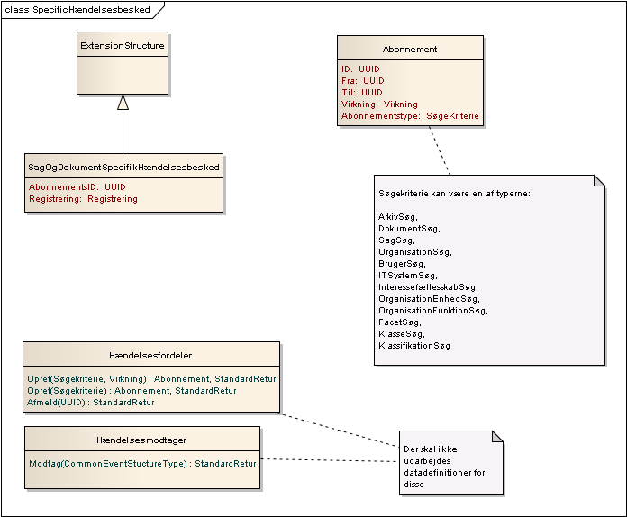
Figur 2

Operation API for Hændelser (Events)
Since we will not require infrastructure that we operate with a minimalist event model, and a push notify architecture. This solution can be offered in both a sophisticated enterprise environment, but also in an environment with lots of legacy - it's enough to have a URI.

Hændelsesfordeler (Event Distributor)
Event Distributor, which has operations Create and Cancel.
At Create specify a search criteria that represent the resources that you are interested in receiving events.

Hændelsesfordeler
Opret(AbonnementInputMeddelse): Abonnement
Afmeld(abonnementsID:UUID): StandartRetur
Tabel 1

HændelsesModtager(Event receiver)
This is a call-back URI, then an interface you must have in order to receive an incident.

HændelsesModtager
Modtag(GenerelHændelse):StandartRetur
Tabel 2

Referencer
Notation | Reference
[Fowler] | Martin Fowler, Temporal Pattern. http://martinfowler.com/ap2/temporalProperty.html
[UML] | Martin Fowler, UML distilled.
[Etutorials] | Etutorials.org http://etutorials.org/Programming/UML/Chapter+6.+Class+Diagrams+Advanced+Concepts/Parameterized+Class/

Dette afhænger af det enkelte ForretningsObjekt. Som udgangspunkt skal det være obligatorisk at have de elementer med, som er obligatoriske i informationsmodellen, men som ikke kan tildeles en fornuftig default værdi.

